|  |  |  |
| --- | --- | --- |
|  |  | Rutland south Beat  **Crimes of Note: Decemeber 2023** |
| PC Pete Icke 2113 **As part of our ongoing drive to reduce demand did you know that you can report a "NON-EMERGENCY" crime and find lots of useful information on our new improved web site.** [**www.leics.police.uk**](http://www.leics.police.uk)  Please look out for any vulnerable people in our community and if at all concerned, please raise this concern to the relevant agencies. You can also raise these concerns with myself.  **Parish Meeting:** If any parishes would like the beat team to join them, please let me know (subject to being on duty). Contact WEBSITE:[www.leics.police.uk](http://www.leics.police.uk) |  | Burglary 3rd - Woolfox – Break into building site with high value mechanical machinery stolen.  12th - Empingham attempt residential break - suspects have tried the rear pantry window with an object but get disturbed by the aggrieved and run off. Criminal damage - theft 22nd – South Luffenham business - Theft of old cooking oil from drums Assault 30th – Braunston in Rutland - person assaulted during activity event. vehicle crime 9th – 11th - Normanton – theft from motor vehicle  10th – Morcott - theft from motor vehicle  19th – Edith Weston - Attempt theft of motor vehicle  21st – Braunston in Rutland – vehicle has tyres slashed. Other 2nd - Wing – possession of drugs  20th Glaston – officers stop vehicle and arrest person for drug offences.  **In Summary** |

Vehicle crime with theft from has been highlighted this month. Please try and park your vehicle where it is clearly visible and well lit if possible. If you are away from home then also look out for areas with CCTV, which can put criminals off. For vans parking with your sliding door or back doors close to a wall will make it harder for thieves to remove items if they do break in. Always lock your vehicle even if you leave it for a few minutes.

We have had one attempted residential break in the month of December but luckily the owner was in, and offenders fled. As we are now into the darker nights, please remain vigilant. Ensure your doors and windows are always locked and leave lights on if you go out.

We have had one commercial / rural breaks this month on the south beat with mechanical machinery stolen - rural locations including building sites and Farms are often targeted as their plant equipment are highly desired commodities due to demand exceeding worldwide supply. We continue to run operation Vitality for rural crime with extra officers out patrolling.

If you see witness or suspect anything similar happening, please call the police. Your call may be all that’s required to catch them in the act!



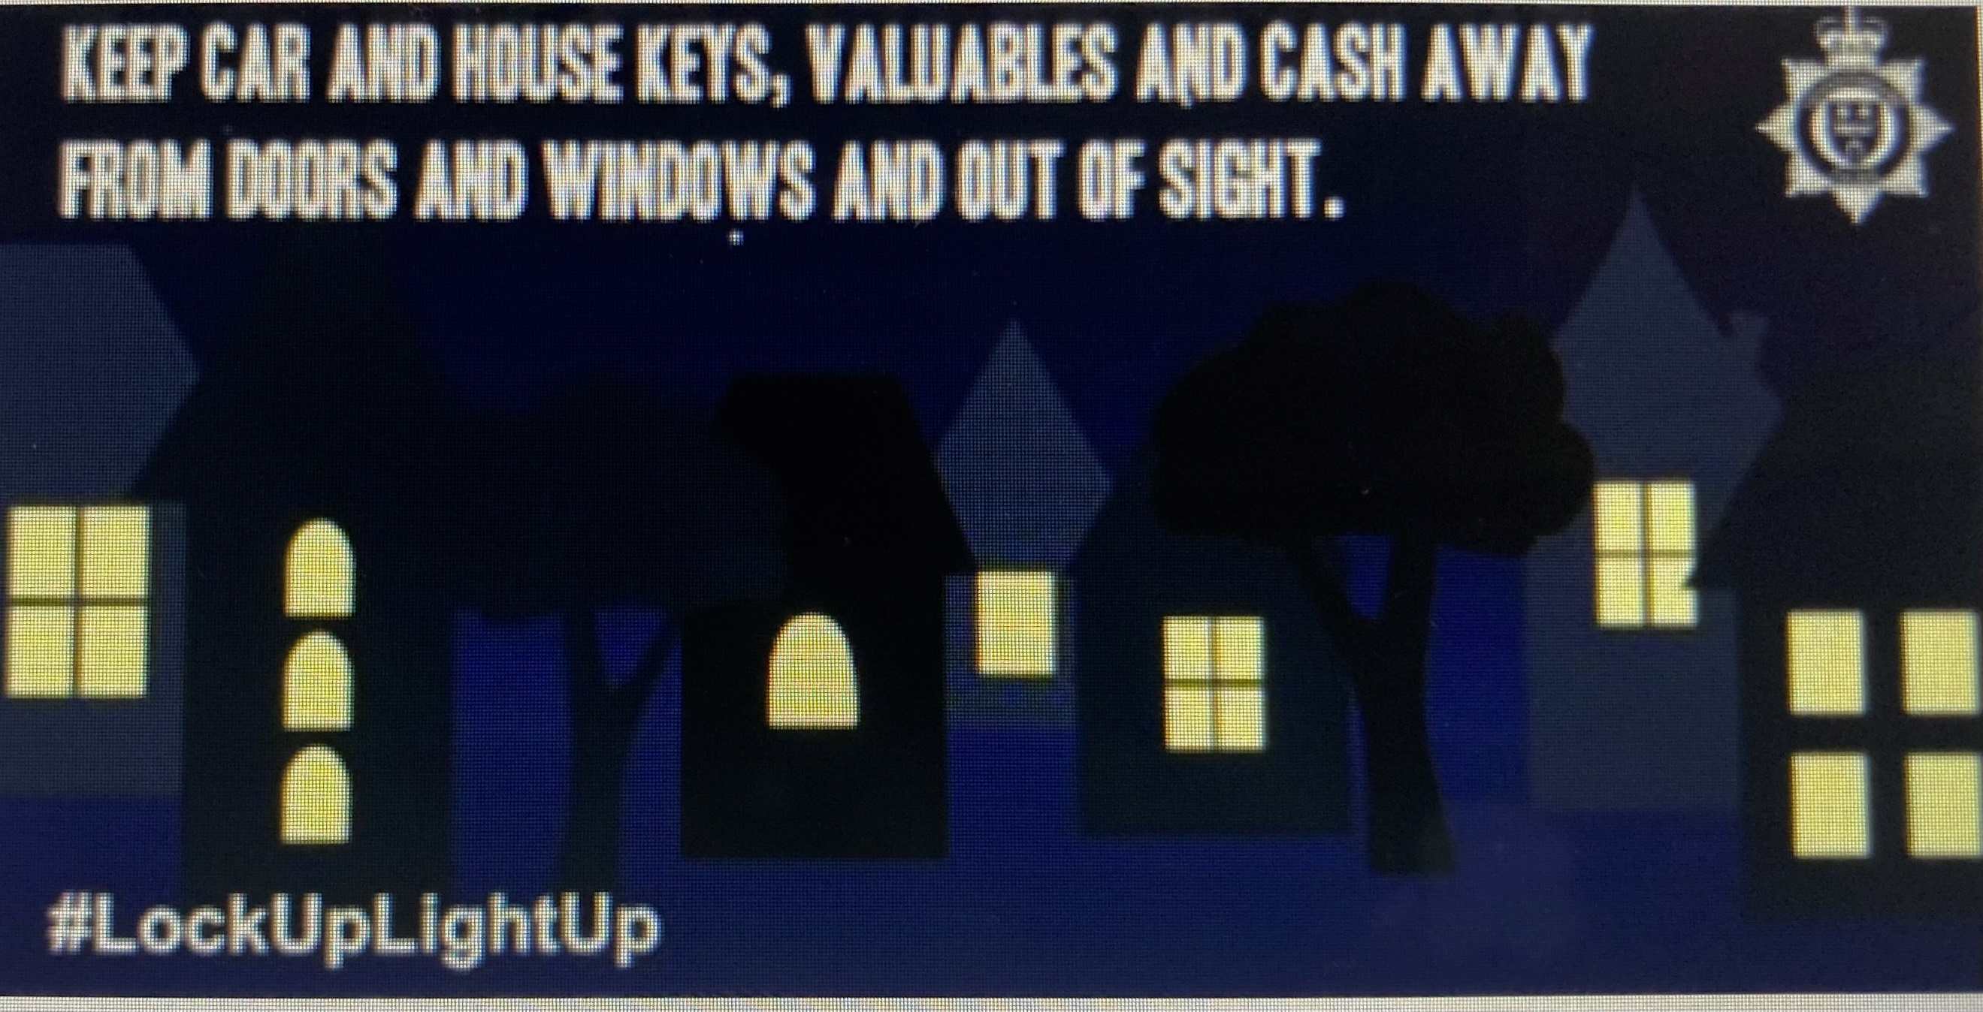

Burglars will use a variety of ways to avoid being noticed.

They don’t want to be seen or heard by a neighbour or passer-by because they will feel exposed and identifiable.

Distraction burglars will pretend to be someone they are not, so it’s important you are aware of the common methods they will use to get you to let them into your property.

Here’s some useful advice, firstly on helping to keep burglars out by giving them no hiding place and, secondly, on how to prevent a distraction burglary.

**Keep it visible**

You’d think that it would be best to make a property less visible from the street, and to keep it hidden from prying eyes behind overgrown bushes, trees, high fences or walls. In reality, all that this serves to do is make it easier for a burglar to get close to a home unnoticed and provide somewhere to hide while carrying out a burglary or theft from the property.

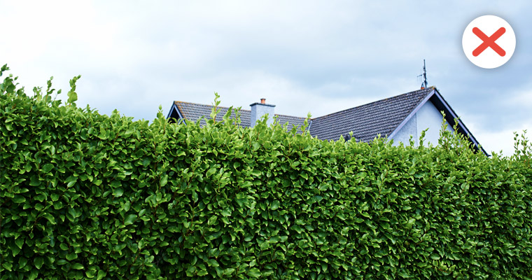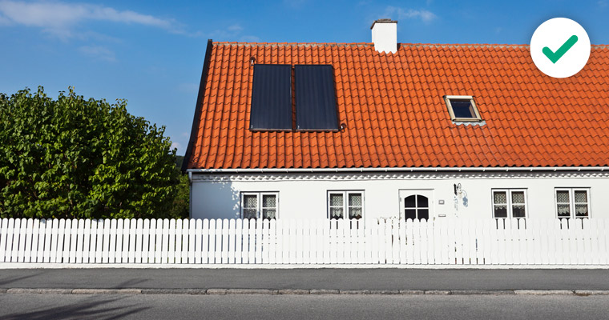

1. Lower fences at the front around one-metre high are preferable to high fences as they allow for a clear view over the top and don’t provide cover for anyone wishing to hide.
2. At the rear and sides, taller fencing is recommended to prevent easy access.
3. Trellis, thorny plants, or a suitable anti-climb topping such as plastic spikes make it difficult for anyone climbing over a fence or gate.
4. Planting prickly or barbed shrubbery along boundaries and fence lines acts as an effective natural barrier.
5. Gravel driveways and paths will make sure you hear anyone approach.

For more information on creating a boundary, visit our [advice on criminal damage](https://www.leics.police.uk/cp/crime-prevention/protect-home-crime/property-vandalism/)

### Distraction burglary

Distraction burglars pretend to be someone they are not in order to gain entry to your home.

#### Common methods used by distraction burglars

* pretending to be from a care agency, the council or a utility company investigating a gas or water leak
* seeking help to leave a note for a neighbour or even asking for a drink of water if they claim to be thirsty or unwell
* claiming to be in a hurry or emergency and needing to get into your home quickly
* working in teams, with one person distracting you while the other searches your home

#### How to prevent it

There are a number of things you can do to prevent distraction burglary. Always remember "if in doubt, keep them out":

* use your door viewer to see who’s there
* if you open the door put the chain on first
* always ask for ID and check it with the company before letting somebody into your home
* use the phone number advertised in the phone book or online, as the number on their identity card could be fake. For a utility company, call the customer service department. Close the door while you do this
* remember that genuine callers won’t mind checks. If you feel at all unsure, schedule a time for the caller to come back when a friend or relative is there
* for pre-planned appointments with utility companies, a password scheme can be set up

If you feel threatened or in danger by the presence of the caller, call [999](tel:999).

**NEIGHBOURHOOD LINK**

We continue to encourage local residents to have their say through Neighborhood Link surveys and keep all residents that have signed up to this aware of issues happening in Rutland.

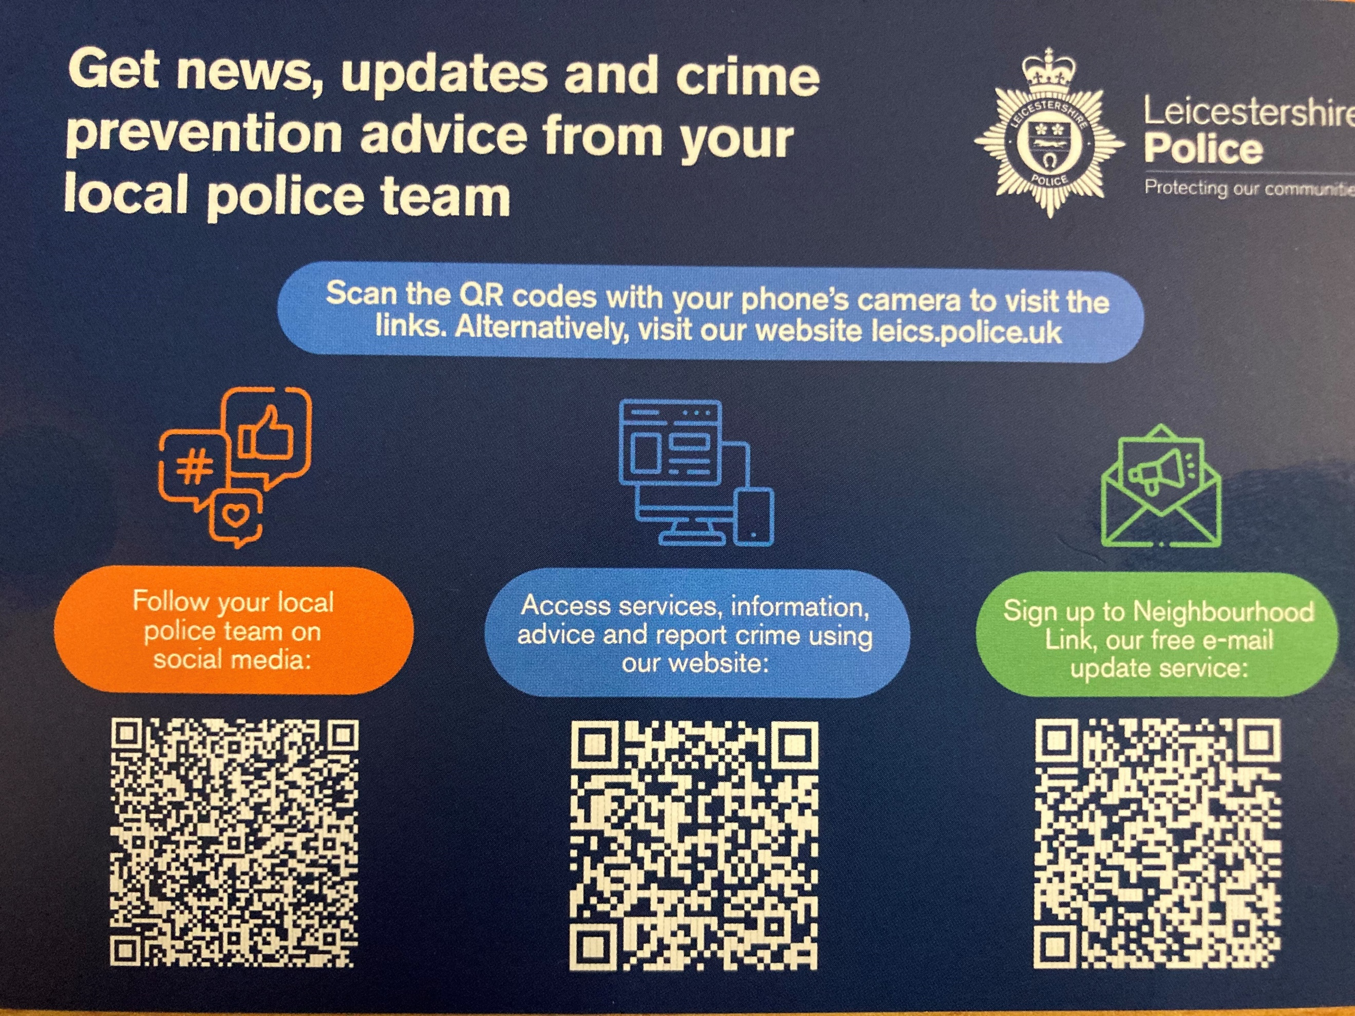

## Beat PRIORITIES

Nuisance Motorbikes

Road Safety Issues

Rural Crime/farming equipment

**Operation ENFORCE**– has been created to reduce speeding and road safety issues including nuisance motorbikes especially at weekends.

We continue to conduct speed monitoring and enforcement utilising the SL700 laser speed meter on the beat

